Enabling Compatibility Mode in IE10
In order for some EE application functionalities to work properly in Internet Explorer 10, compatibility mode must be enabled.
- Open Internet Explorer 10 and then press the Alt key.
- On the Tools menu, click Internet Options
- Go to the Security tab, select Local Intranet and click on Sites
- In the Local intranet window click Advanced
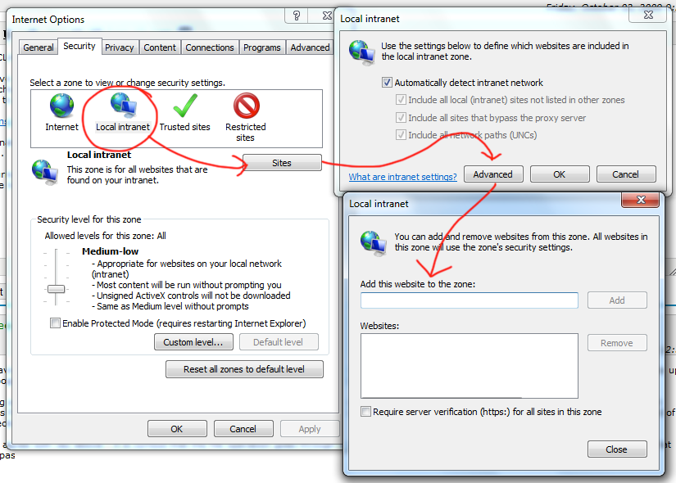
- In the next Local intranet window add the following sites:
  - https://ee.labour.gov.za/dmiso/
- Click Close
- Now go back to the Tools menu
- Select Compatibility View settings.
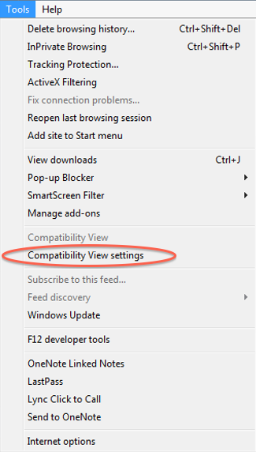
- The Compatibility View Settings window will open.
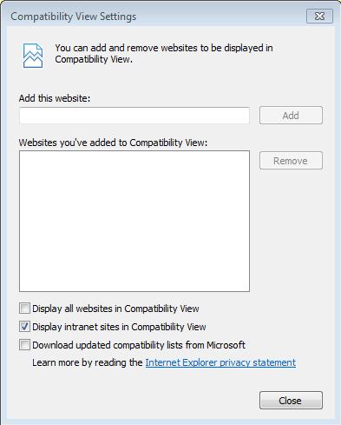
- You will now see a list of the site previously added.
- Make sure to select Display intranet sites in Compatibility View.
- Click Close.

Or just click on the selected icon as displayed on the screen below:
